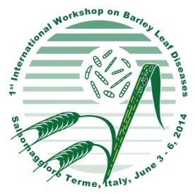
IWBLD - 1st International Workshop on Barley Leaf Diseases
SalsomaggioreTerme, Italy, June 3-6, 2014
“Healthy Barley for Healthy Feed and Food for the Future”

Attendee
First Name:……………………………………………............…...........................................................
Family Name:………………………………………………………........................................................
Department:………………………………………………………..........................................................
Organization:……………………………………………………….........................................................
Postal Address:……………………………………………………........................................................
City:………………....................... Postcode:……………. Country:…………….................................
Email:………………………………………………….......... Phone:.....................................................

Registration type
Normal rate: 170 € until 15 April 2014 □
200 € from 15 April 2014 □
Students (official certificate required): 80 € □
Accompanying Person: 50 € □

Payment details
Payments (in Euro) must be done via bank transfer to:
Bank name CARIPARMA - Cassa di Risparmio di Parma e Piacenza, Fiorenzuola d’Arda
Beneficiary IWBLD organizing committee
IBAN Code IT68P0623065310000030799474
BIC/SWIFT Code CRPPIT2P020
Causal: Please write “Registration to IWBLD” followed by your Full Name

Please return the present form to alessandro.tondelli@entecra.it or by Fax (+39 0523983750) along with a receipt of your bank transfer. Registrations will be confirmed after payment is received.
Accommodation and Conference dinner are not included in the registration fees.
As for the treatment of the participants’ personal data according to the Italian Law 196/2003, all the data provided will be treated for the sole purposes related to the services required.

